**The design**

The gallery is a simple app where one can view pictures and save then on their computers. The pictures are obtained from unsplash. The first page displays 30 pictures in which one can scroll down to view more other pictures. I have used react-infinite-scroll-component that aids in pagination by allowing users to scroll down to view more pictures.

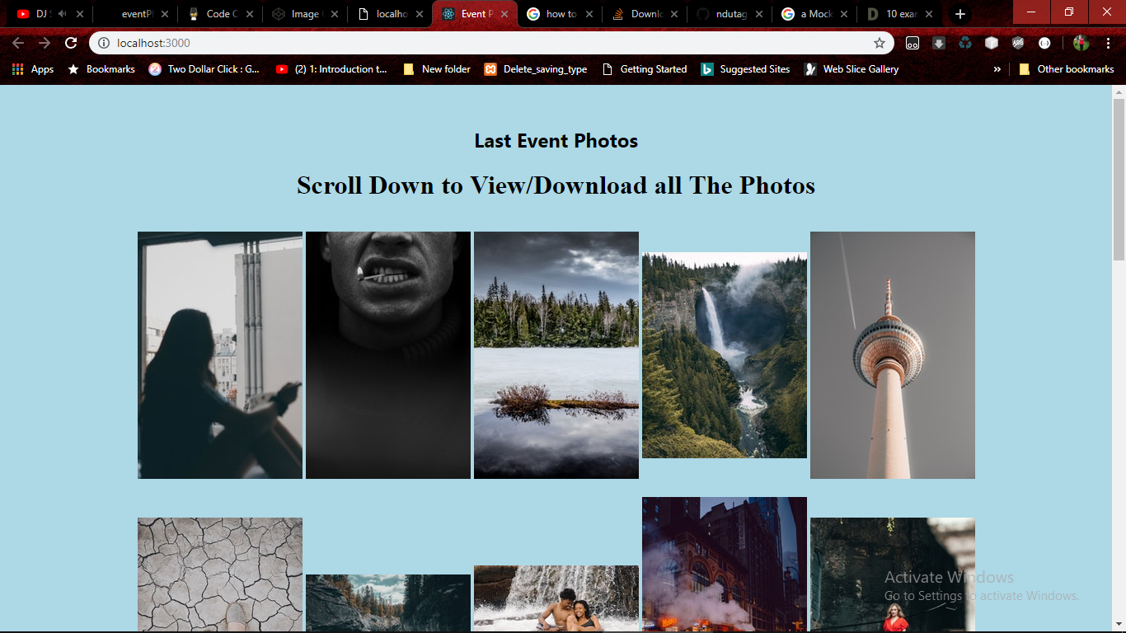

**Why I chose the design**

I have used react.js as my JavaScript framework since it is user friendly and I find it comfortable to use APIs with it.

I have pushed my work on git hub, one can access it via <https://github.com/ndutagrace25/youth_event_photos.git>